K. Curtis Charles

Instructor Renee Dodge

CIS134: Web Style and Design

June 2, 2024

Website Evaluation

For this website evaluation project, I have selected the "Pacific Northwest X-Ray Inc." website, which is absolutely atrocious (Pacific Northwest). Everything about its design is glaringly outdated, yet it still functions as an outlet for buying x-ray imaging equipment and accessories. The copyright shows “©1997-2024” but it would appear as though it hasn’t been updated since 1997. Here are the site’s details followed by my qualitative review:

Website Name: Pacific Northwest X-Ray Inc.

URL: <https://www2.pnwx.com/>

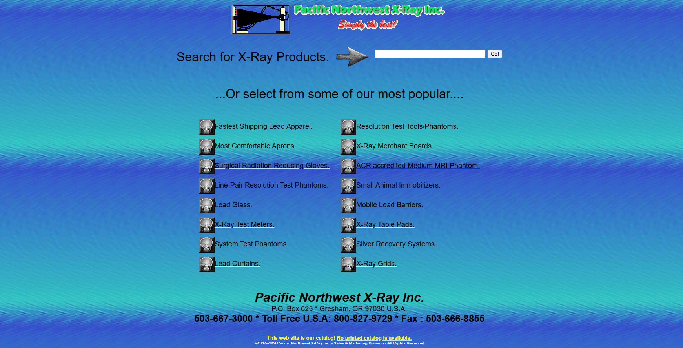

The Pacific Northwest X-Ray website uses a subdomain, hence the “www2” instead of the common “www.” This isn’t much of a problem in itself, but it does make the URL harder to remember. The site’s main problems begin with its user-friendliness (or lack thereof). It is not user-friendly due to its outdated design and non-intuitive interface. The change I would implement to correct it would be to simply modernize the design and improve the interface to make it more intuitive. Navigation is inconsistent and confusing, making it difficult for the user to find information. I would add a consistent navigation bar across all the site’s pages to address this issue (What Is Usability).

The home page is also incredibly cluttered with dense text information and lack of any obvious visual hierarchy. Simplifying the layout and effectively using white space would reduce the clutter and give it a more modern look. A new color scheme would also help quite a bit in pulling this site out of the nineties. I would suggest redesigning it all using modern design principles, ensuring appropriate use of color, spacing, and hierarchical structure. I’d also replace all the clipart images and GIFs with higher resolution visuals.

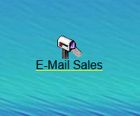

Finally, all the links need to be checked and the text proofread to ensure accuracy and professionalism. I didn’t notice any typos, surprisingly, but I did notice a broken link. The “E-Mail Sales” link that’s present in the footer of most pages does not function and leads to a unique 404 error screen, in which the image is slightly distorted and off-center.

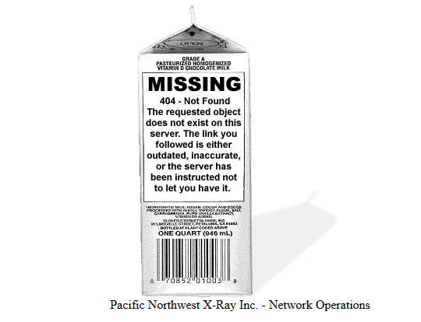

Here is an additional evaluation of the Pacific Northwest X-Ray Inc. website based on Jakob Nielsen's 10 general principles for interaction design (Nielsen):

1. Visibility of System Status:

The website does not provide users with clear feedback on all their actions, such as loading indicators or confirmation messages. I’d also expect, since this is an e-commerce site, for there to be some indication of stock levels. There’s no sign of the availability of items or the time it’d take to manufacture and ship more. It’s not a complete failure in this department though, since the oddly colorful links do change colors once they have been clicked.

2. Match Between System and the Real World:

The language and jargon used on the site is somewhat technical and may not be intuitive for all users. I’d suggest using simpler, more user-friendly terminology that better aligns with user expectations. A glossary of some sort may also be helpful.

3. User Control and Freedom:

Users have limited control on this website. There is no persistent “back” button to speak of and the “home” link is not present on every page as it should be. A consistent navigation bar would improve this situation substantially (What Is UI Design?).

4. Consistency and Standards:

The website lacks consistency in navigation and design elements, leading to user confusion. The most obvious problem is one I’ve mentioned several times at this point; it has no navigation menu. The design and navigation elements should be consistent across all pages to ensure a cohesive user experience (What Is UI Design?). Also, there is not a mobile-formatted version of this site and that should be a priority in this day and age.

5. Error Prevention:

There are no mechanisms in place to prevent user errors since the site isn’t even equipped to manage any sort of input data. There is no form validation because there are no forms and there are no confirmation dialogs because there’s nothing to confirm. I’m assuming they only take orders via a printed order form to avoid having to deal with any user input whatsoever, which is definitely a bad decision in 2024. There is, however, the single case of the aforementioned 404 error page when clicking the broken “E-Mail” link.

6. Recognition Rather Than Recall:

Users have to remember information and navigate through complex menus to find what they need. Simplifying the navigation and using recognizable icons and labels would aid user memory (What Is Usability). I think they made an attempt at this, but used horrible, low-quality clipart images to do so, which are not effective.

7. Flexibility and Efficiency of Use:

The site lacks shortcuts and intuitive menus. This does not cater to novice or expert users.

I would introduce shortcuts and advanced options, such as sorting of products and advanced search forms, for expert users while keeping the main navigation simple for novices.

8. Aesthetic and Minimalist Design:

The website is cluttered and visually overwhelming, with too much information presented at once. It should be redesigned with a minimalist approach, focusing on essential elements and effective use of whitespace (Nielsen). It also desperately needs an overhaul of its color palette and an improved background to improve readability.

9. Help Users Recognize, Diagnose, and Recover from Errors:

The only error message on the site is the milk carton 404 error mentioned earlier. That being said, the site is so barebones that it doesn’t need any more than that as it stands. Once the navigation system is revamped there should be room to implement these standards.

10. Help and Documentation:

There is little to no help or documentation available for users needing assistance. There is a help section with user guides and contact information for support, but it is hard to find and the small, thin font makes it all difficult to read against the background. It would make the most sense to arrange this information in the format of an FAQ section (What Is User Interface).

Works Cited

Nielsen, Jakob. “10 Usability Heuristics for User Interface Design.” Nielsen Norman Group, 20 Feb. 2024, www.nngroup.com/articles/ten-usability-heuristics/.

“Pacific Northwest X-Ray Inc..” Pnwx.Com, www2.pnwx.com/. Accessed 2 June 2024.

“What Is Ui Design?” Figma, www.figma.com/resource-library/what-is-ui-design/. Accessed 2 June 2024.

“What Is Usability - the Ultimate Guide.” The Interaction Design Foundation, Interaction Design Foundation, 6 Dec. 2023, www.interaction-design.org/literature/topics/usability.

“What Is User Interface (UI) Design? - Updated 2024.” The Interaction Design Foundation, Interaction Design Foundation, 19 Apr. 2024, www.interaction-design.org/ literature/topics/ui-design.